35 km for 35 years relay

To celebrate MRWSA 35 years in Rocky Mountain House

Pledge Form
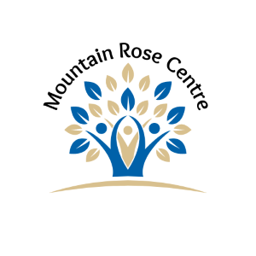
Name: __________________________________________________________ Phone Number: ____________________ Cell Number: __________________
(of entrant walking)

Address: ___________________________________ City/Town, Province: __________________________________ Postal Code: _____________________

“35km for 35 years” is being held on May 31,2025. This is a fundraiser for the Mountain Rose Women’s Shelter Association (MRWSA). All donations/pledges of $10 and over will receive a charitable tax receipt. It is important that you provide a full name or full business name and complete address to enable us to mail the receipt to you. All receipts will be issued & mailed the week following the event. MRWSA is committed to providing a safe shelter to women and children who have involved in domestic violence disputes or otherwise involved in violence and requiring a safe place to begin a new. We look forward to a safe future for all. “35km for 35 years” .
Mountain Rose Women’s Shelter is a registered non-profit association.
All cheques payable to Mountain Rose Women’s Shelter Association
Donor Name | Phone Number | Address | City/Town, Province | Postal Code | Amount Pledged | Amount Paid | Tax Receipt No.

